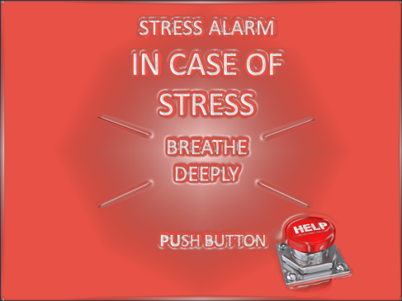
Breath can be one of the most powerful things to help anchor us into the present moment.
We breathe 20,000 times a day automatically and thank goodness, or we would be spending all our time focusing on inhaling and exhaling with little time for anything else. Yet because it is so automatic, we often forget just how important it is to our lives. We can live for weeks without food and days without water, but take our oxygen away and we quickly wither away and die. So it is probably a good idea to take an active interest in our breathing. Try telling a scuba diver to ignore their air tank, a long distance runner to hold their breath during a marathon, or an expectant mother who is taught Lamaze techniques that focusing on breathing doesn't matter.
When we get stressed, anxious, worried, or fearful, our breathing changes quite dramatically. The pace of our breathing quickens and we start breathing much more shallowly which significantly reduces the oxygen supply to our body and brain. In those times of stress, anxiety, and worry, simply paying attention to the breath has the power to calm us down by helping to activate our parasympathetic nervous system. Think of a parachute. What does a parachute do? It slows us down. Mindful breathing practice helps us release our parachute.
Mindful Breathing
What is mindful breathing? The simplest explanation for mindful breathing I ever heard came from renowned Harvard medical doctor Herbert Benson, the person who coined the phrase the Relaxation Response. During a lecture I attended by Dr. Benson, he talked about how simple it is to elicit the relaxation response by using your breath. I paraphrase here. Just place your attention on your breath and when your mind wanders off, bring it back to your breath.
Practicing Mindful Breathing
Initially, find a comfortable spot where you will not be disturbed for this practice. After a few times practicing however, you can do this where ever you may be... on a crowded train or bus, at the mall, in your car traveling with your family or co-worker, walking the dog, in a meeting, at your desk, jogging, playing tennis, etc.
The beauty of mindful breathing is that you can do it almost anywhere.
Settle in to a comfortable space. Sit up straight but soften your neck and shoulders.
- Simply notice your breath. Don't try to change anything about your breath, just keep your awareness on it. Notice from where you are breathing... belly, chest or nose. Notice the pace of your breath. Are you breathing fast or slow? Notice how deeply or shallowly you are breathing. Notice how it feels to breathe with your focus on your breath.
- If your mind wanders to a thought (I am not doing this right, this is boring, or I wonder what's for lunch), bodily sensation, or noise from the environment, and know it will, gently guide it back to your breath. Use your breath as an anchor to help ground you in the present moment and do your best to keep your awareness on it.
Variations of Mindful Breathing
Some people find it helpful as they breathe in to silently say, "I am breathing in" or "In" or "Inhale" and as they breath out to say, "I am breathing out" or "Out" or "Exhale. Others find it helpful to count upwards from 1 to 4 or 6 on the inhale and back from 6 or 4 to 1 at the exhale. Just remember, anytime a thought (Like I am not doing this mindful breathing right or this is hard), feeling, or bodily sensation takes over, just bring your attention back to your breath, the word, or the number. And if you forget the number, you can always just bring your attention back to your breath and forget the numbers.
Space Breathe –You might have noticed a slight pause or pivot point in between your breaths. There is a slight pause or space after you have inhaled, just before you exhale. Notice that now as you breathe in. There is also another pivot point or gap after you have exhaled just before you inhale. For this variation of mindful breathing, just focus on the space in between the breaths. So while you are doing your mindful breathing, just start to put your attention the space in between the inhales and exhales.
It may take you a little while to notice that space in between your breaths. As one of my students said, she noticed that she was able to find the space after the exhale much easier than the space after the inhale. Just stay with it. Once you find that space, see if you can then extend the space just a bit. Pause slightly longer in between each inhale and exhale. Many of my mindfulness group students have found this particular experience the most powerful for when we really tune into that space/gap/pause, you will have found your true center. In that gap is your full creativity and your full power over stress, tension, anxiety, worry, or whatever you encounter.

